Sprint 4 Plan

DnD Assistant App  
5/18/22–5/31/22

Goal: Create a website that allows users to save a character and see it

User Story:

1. As a player, I want to create a character, so that I can play the game (5)
   1. pushing character information into database
2. As a player, I want to save my character, so that I don’t have to create a new one every time (2)
   1. Taking previous information and pushing to firebase
3. As a player, I want a walkthrough of the process of creating a character, so that I don’t have to google it (3)
   1. character creation process tips along the way
4. As a user, I want to be able to see my saved characters (5)
   1. layout of character display page information
   2. pulling information from database and putting onto character display page

Team Roles:

* Brian
  + Product Owner, Developer
* Brandon
  + Developer, Scrum master
* Mateo
  + Developer
* David
  + Developer
* Cynthia
  + Developer

Initial task assignment:

* Brian
  + Tips
  + Scraping
  + Front-end
* Brandon
  + Character display page
  + Back-end
* Mateo
  + Front-end
* David
  + Fetch information from DnD api
  + Character display page
  + Back-end
* Cynthia
  + Front-end
  + Character display page

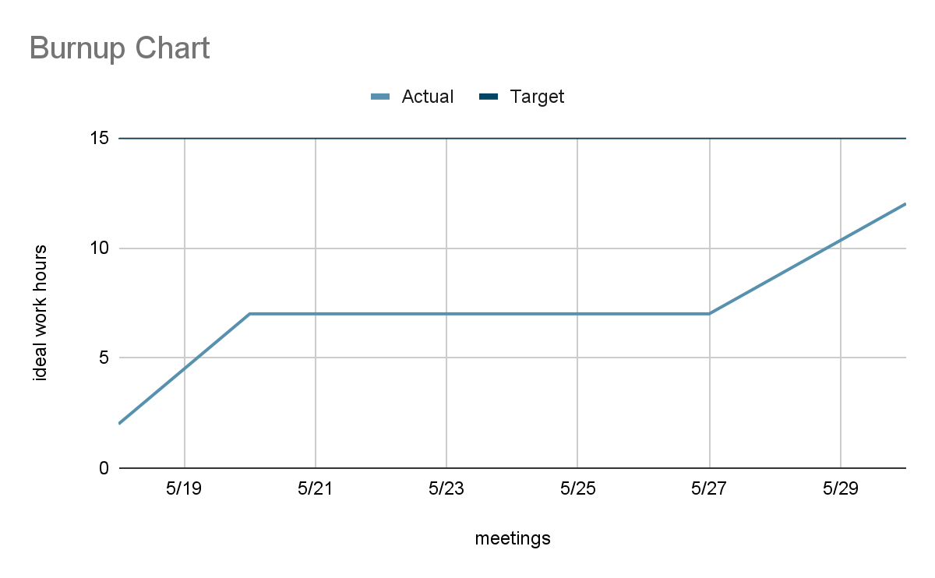

SCRUM board: <https://trello.com/invite/dndassistantapp/2ea0443f7a8af527f19901d5f9fc6dc9>

SCRUM times:

* Monday 7:00 pm
* Wednesday 4:00pm
* Friday 4:30 pm (TA)
* Friday 5:15 pm